

Computer Networks

Lab Report

Name ：梁卓文
Student ID ：202130320915
Class ：计算机全英联合班
Collaborator(s) :杨竣尧、谭演锋、郭荣锦

Task 4 Socket Programming
- Experimental Purposes
Objective：
- Master the basic principles and methods of Socket network programming
- Understand the underlying principle of operation of Socket deeply

- Requirement：
- Basic: Implement a client and a server similar with ftp protocol; complete the basic function of file transfer.
List the files/directories
Change working-directory
Download file/s
Upload files/s
Create/remove files/directories
Etc…
- Submit content: document report （include design document, using explanation）, source code，the content above store in 2 folder apart（Doc、Src）
Explain the design of your file transfer program(FTP).
High-layer encapsulation Socket can not be used (like java class library, MFC and so on)

- Explain the usage of socket.h or winsock.h

3. Experimental Environment
Platform: Windows
Developing Language: C
Developing Environment: Visual C++
Group: 4 members/group

- Design Document
- The structure of FTP(Part of)
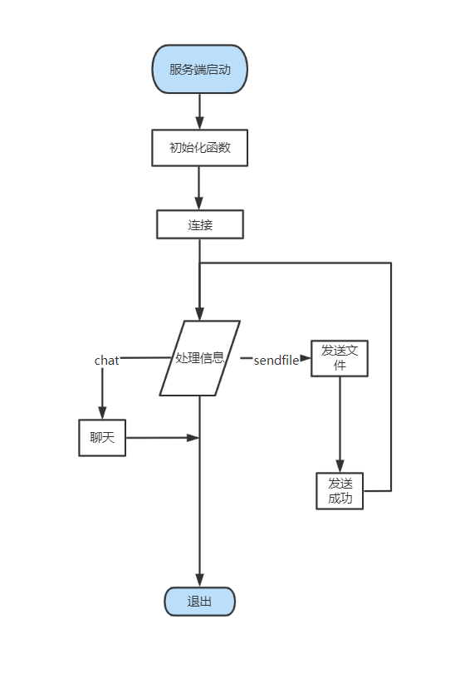
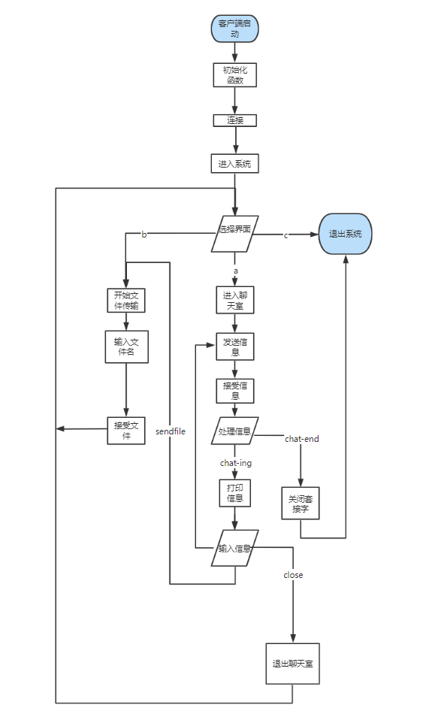
Figure. Server and Client
- Overview of implementation
Processing information is the difficulty and breakthrough point in this development process. In order to combine chat and send files into one program, flag bits are specially set to mark the attributes of sent information. The sent information is encapsulated in a structure, and the two parties process it according to the header information of the sent information when communicating. The server only needs to call a processing information function to run, and the client independently designs the processing function of sending files and the processing function of chatting according to the needs selected by the user. The advantage of this is that the implementation of the program is more organized, the development is more simple and specific, and the later is easy to maintain, optimize and improve.
- Implementation of system processing information
Due to the limitation of the size and capacity of the send cache, it is difficult to transfer large files, but in the actual application environment, simple file transfer can not meet the needs of its users, if the transfer of files is one-time, the system often causes file transfer failure or information loss due to insufficient allocation of memory. In order to solve this problem, the design of this course takes the idea of: the server splits the file to be sent, transmits the data a few times, the client splices the fragments of the data, writes a few times until the information is received.
Here is the general idea behind how the system processes information:
Process of sending file information:
- The client input the file name and send it to the client, marking position 1;
- The server receives the file name, finds whether there is a file, sends the file size to the client, marks the location 2, and opens up the memory space of the send cache; If not, a message without file is sent, marking position 6;
- The client receives the file size according to the file size to open up memory space and send a request to accept, marking position 3; Receive no file message continue to enter the file name and send, marking position 1;
- The server begins to send the file after receiving the request, marking the position 4; After the transmission is completed, send the successful transmission signal, marking the position 5; Close the connection.

- The implementation of unpacket transmission of files
Sending large files adopts the idea of unpacking and processing the sent information with flag bits. The two parties determine what to do next based on the packet header information.
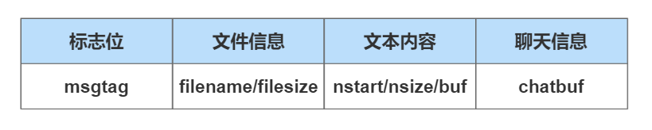
图2.2.2 设计的协议格式
In order to more convenient understanding of its implementation principle, the code is attached to supplement the explanation

enum MSGTAG
{
MSG_FILENAME = 1,//file name
MSG_FILESIZE = 2,//file size
MSG_READY_READ = 3,//tell client be ready to read
MSG_SENDFILE = 4,//sending file
MSG_SUCCESSED = 5,//succeed in sending file
MSG_OPENFILE_FAILD = 6,//failure in opening file
ENDSEND=7,//stop sending file
CHAT_END = 10，//end of program
CHAT_ING=11//start chatting
MSG_DIRECTORY = 12,//make a directory
MSG_DELETEFILE = 15,//delete file
MSG_UPLOAD = 16,//upload file
MSG_PATHNAME = 17, //change path
MSG_UPFILENAME = 18, //upload-first step
MSG_UPFILE = 19, //upload-second step
MSG_UP_READY_READ = 20 //upload-third step
};

#pragma pack(1)
#define PACKET_SIZE (10240 -sizeof(int)*3)//定义包的长度
struct MsgHeader
{
enum MSGTAG msgID;//当前消息标记
union MyUnion
{
struct
{
char fileName[256];
int fileSize;
char filePath[1024];
int pathSize;

}fileInfo;
struct
{
char dirPath[1024];
}dirInfo;

struct
{
int nStart;
int nsize;
char buf[PACKET_SIZE];
}packet;
struct
{
char chatbuf[BUFSIZ];
}CHAT;
};
};
#pragma pack()

In order to facilitate the understanding of the function data structure it constructs, the following describes the details of its server unpacking:
- Packet size (PCKETSIZE) : 10204 bytes, where the flag bit accounts for one byte, the file start position accounts for one byte, the packet data size accounts for one byte, so the sent file information accounts for (10240-sizeof(int)) bytes; In particular, when sending the file content (flag bit is 4), it is not necessary to send the file name and file size, so it does not occupy the space of the package.
- Use nstart to record the location of the file information to be sent, that is, the starting location of the file information when the next packet is sent.
- Record the packet data size with nsize.
- If nstart+nsize+1>f-size, it means that this packet is the last packet, and the sender judges the completion of sending according to this condition.

- Using Explanation
  - Introduction
The project uses the existing computer resources to develop a software that can effectively carry out online chat, file transmission and directory processing, which is divided into client and server. The main work is as follows:
- The server is turned on to listen to the client, receive the connection request and establish a connection.
- When the client is opened, it will automatically connect to the preset server. When both sides are opened, the two can start communication.
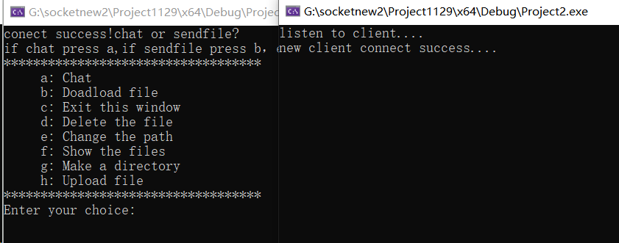
- Print function option on the client interface. The client can select the function to be performed through commands, such as "b" to download the files and "h" to upload files.
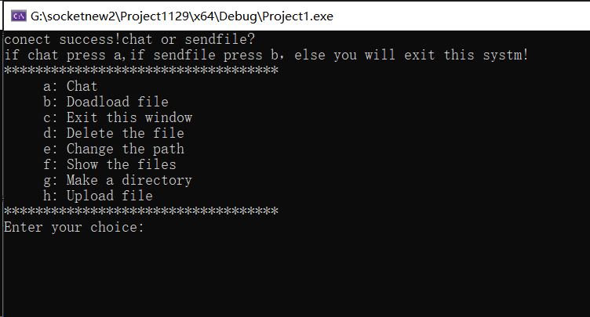
- The server determines which function to perform based on the information sent by the client.
- Chatting
- During the chat, the server can enter the "close" command to actively close the connection to the client.
- During the chat, the client can enter the "close" command to close the connection with the client; Enter the "sendfile" command to terminate the conversation and request to send the file.
- After the server successfully sends the file, the client can choose to continue chatting.
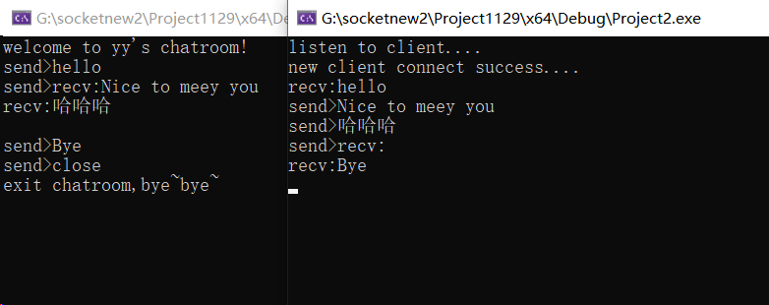
- Download files
Enter the file you want to download. If there is no other path in front of the file, the file path defaults to the root directory of the server.
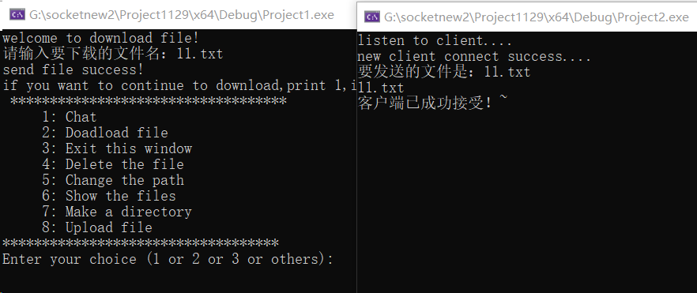
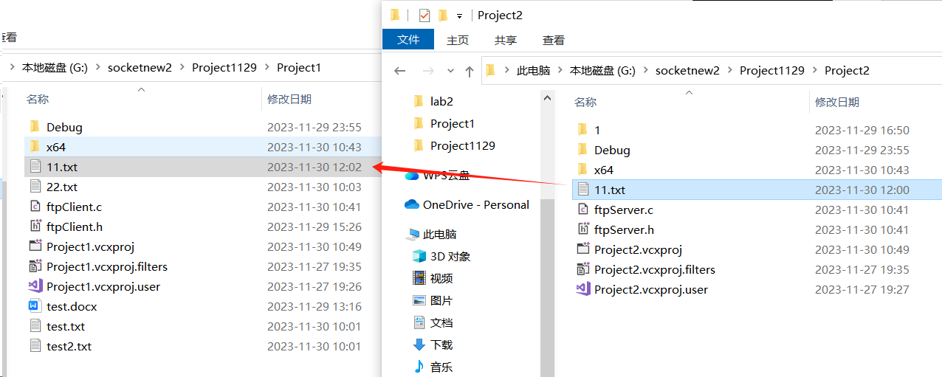
You can see that the server responds to the received request successfully, and the client downloads the file in its path.

- Delete files
Enter the name of the file to be deleted. If there is no path before the file, the file is in the root directory of the server by default.
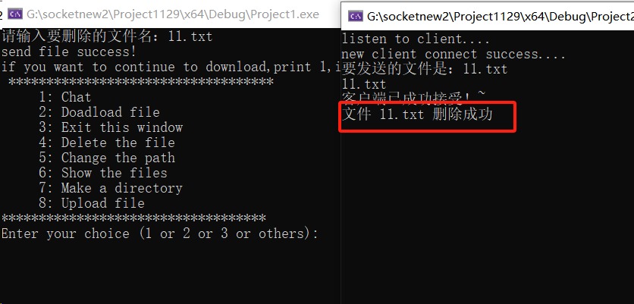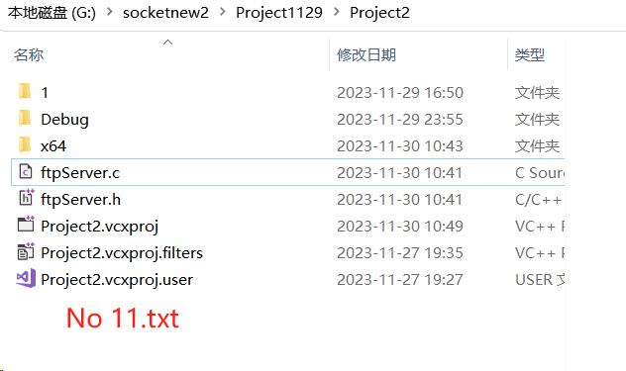
The server replies that the file is deleted successfully. The 11.txt file in the root directory is deleted.
- Change the path
Enter the path you want to change, and the root of the server will be changed to the path you entered
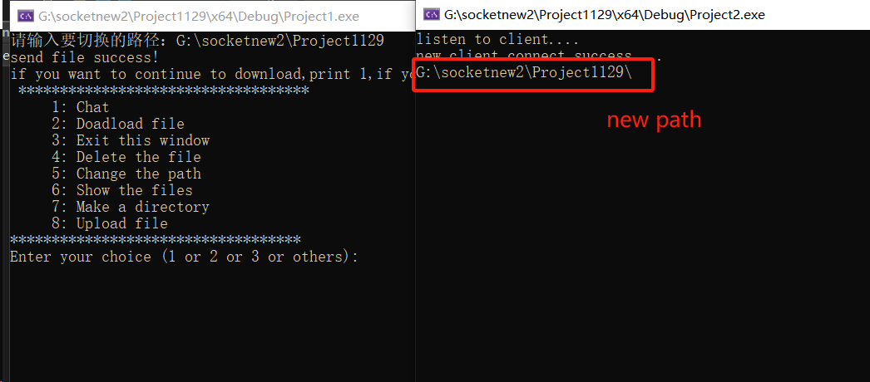
You can see that the server prints the updated path, indicating that the path has been successfully modified.Then use the function of downloading files to test whether the server path has been changed.
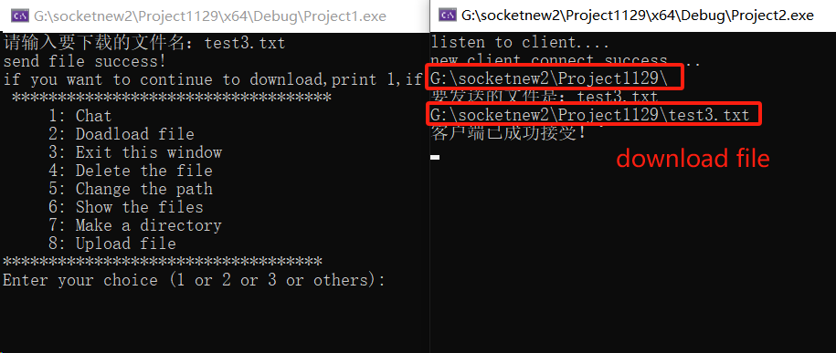
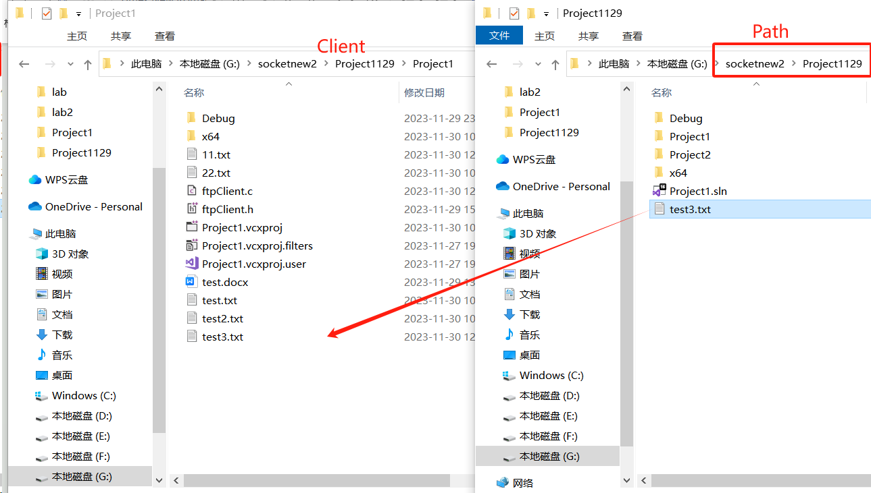
As you can see in the figure above, we changed the path to a directory above the original path of the server, and then entered the file we want to download, test3.txt (without adding an absolute address). Finally, the client successfully downloads the file in its own path, indicating that the path is successfully changed.

- Show the files
Enter the directory or folder path. The client displays all file names or folders in the path.
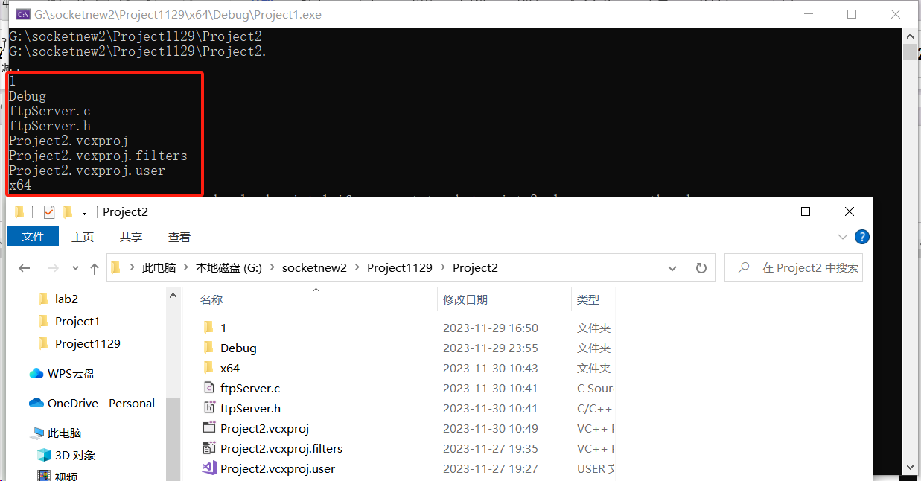

- Make a directory
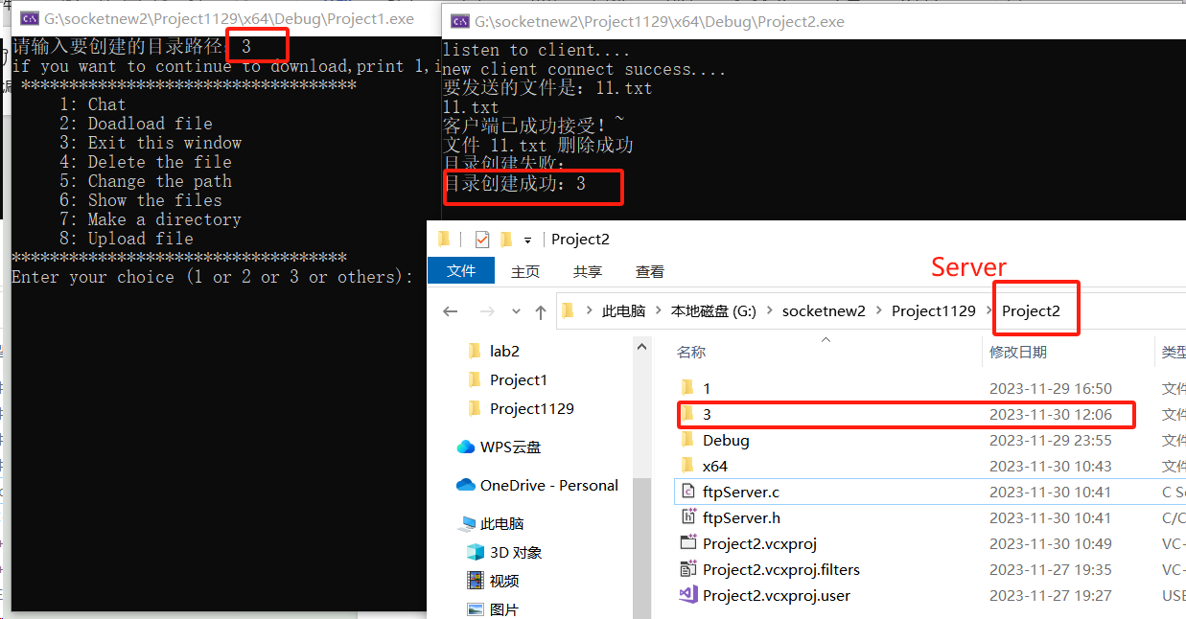
- Upload files
Enter the file to be uploaded. If the address is not absolute, the file in the directory where the client resides will be uploaded by default. The file will be displayed in the server directory.
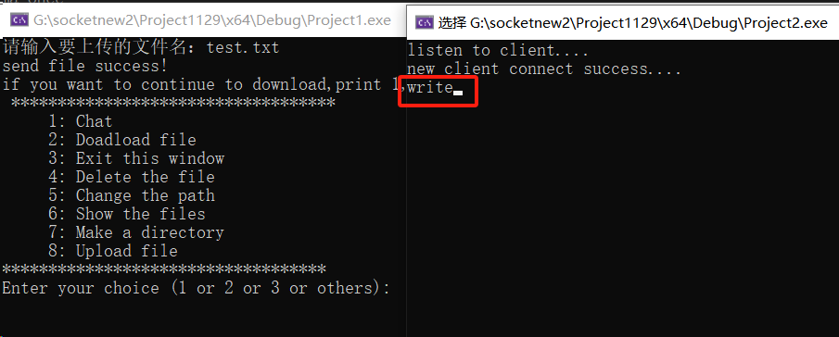
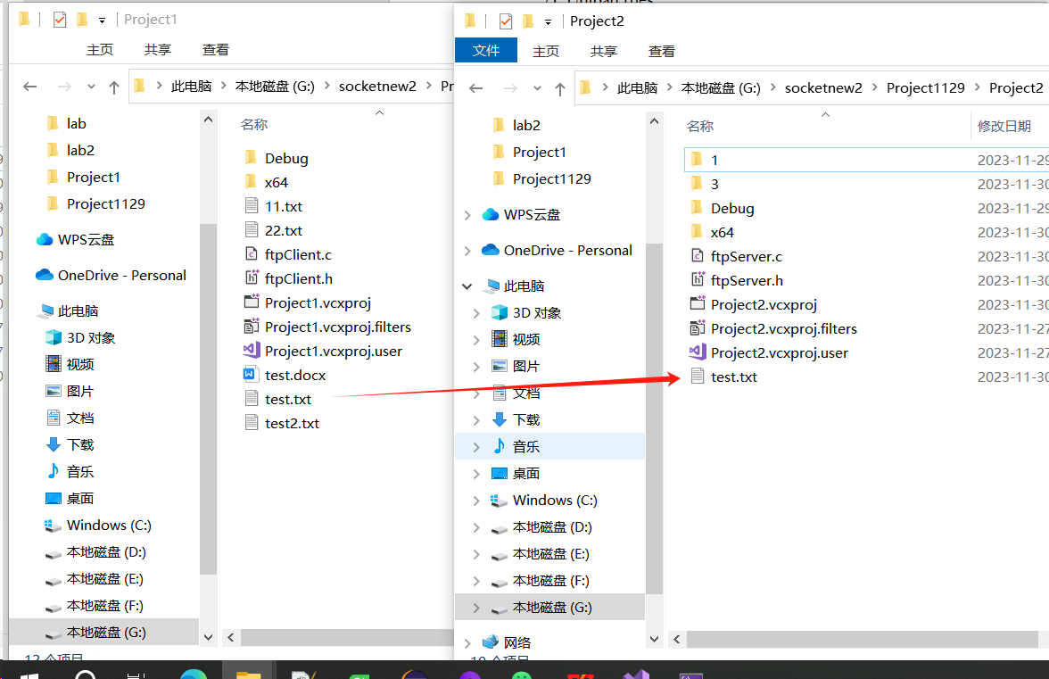
As can be seen from the above figure, the client uploads the file named test.txt, and the server returns "write", which indicates that the file has been written in its own path. You will eventually see the test.txt file in the server path.

- Exit
Enter “c” or “3” to exit the file transfer program(FTP)
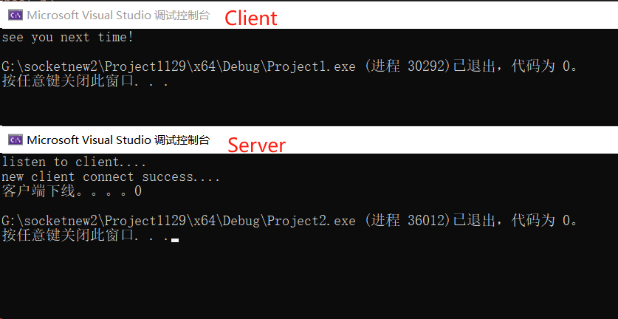

  - Characteristic
- The client can apply to the server for sending large files larger than 100m.
- The communication between the two sides supports the concurrent function, that is, one party can send multiple data or accept multiple data at the same time without blocking.

- Individual report

负责功能的具体实现

Conclusion

Comments and mark:

